Test cases

ТС-1: Calculator's launch in Mozilla Firefox
Requirement: 1. The calculator must be accessible and usable from most PCs and browsers.
Precondition:
Steps | Expected result
Open site https://codepen.io/akaygorodov/full/NwYPjg/ in Mozilla Firefox | Site https://codepen.io/akaygorodov/full/NwYPjg/ is open. You can see calculator on this page.
Postcondition:

ТС-2: Calculator's launch in Google Chrome
Requirement: 1. The calculator must be accessible and usable from most PCs and browsers.
Precondition:
Steps | Expected result
Open site https://codepen.io/akaygorodov/full/NwYPjg/ in Google Chrome | Site https://codepen.io/akaygorodov/full/NwYPjg/ is open. You can see calculator on this page.
Postcondition:

ТС-3: Calculator's launch in Microsoft Edge
Requirement: 1. The calculator must be accessible and usable from most PCs and browsers.
Precondition:
Steps | Expected result
Open site https://codepen.io/akaygorodov/full/NwYPjg/ in Microsoft Edge | Site https://codepen.io/akaygorodov/full/NwYPjg/ is open. You can see calculator on this page.
Postcondition:

ТС-4: Calculator's launch in Opera
Requirement: 1. The calculator must be accessible and usable from most PCs and browsers.
Precondition:
Steps | Expected result
Open site https://codepen.io/akaygorodov/full/NwYPjg/ in Opera | Site https://codepen.io/akaygorodov/full/NwYPjg/ is open. You can see calculator on this page.
Postcondition:

ТС-5: Calculator's launch in Safari
Requirement: 1. The calculator must be accessible and usable from most PCs and browsers.
Precondition:
Steps | Expected result
Open site https://codepen.io/akaygorodov/full/NwYPjg/ in Safari | Site https://codepen.io/akaygorodov/full/NwYPjg/ is open. You can see calculator on this page.
Postcondition:

ТС-6: Calculator's Addition function
Requirement: 2. The calculator must provide a user ability to perform the following basic operations:...
Precondition: Site https://codepen.io/akaygorodov/full/NwYPjg/ is open
Steps | Expected result
Press “1” button with mouse | Value “1” is displayed in input field
Press “+” button with mouse | Input field is empty
Press “2” button with mouse | Value “2” is displayed in input field
Press “=” button with mouse | Value “4” is displayed in input field
Postcondition: Press “C” button with mouse

ТС-7: Calculator's Subtraction function
Requirement: 2. The calculator must provide a user ability to perform the following basic operations:...
Precondition: Site https://codepen.io/akaygorodov/full/NwYPjg/ is open
Steps | Expected result
Press “5” button with mouse | Value “5” is displayed in input field
Press “-” button with mouse | Input field is empty
Press “3” button with mouse | Value “3” is displayed in input field
Press “=” button with mouse | Value “2” is displayed in input field
Postcondition: Press “C” button with mouse

ТС-8: Calculator's Multiplication function
Requirement: 2. The calculator must provide a user ability to perform the following basic operations:...
Precondition: Site https://codepen.io/akaygorodov/full/NwYPjg/ is open
Steps | Expected result
Press “5” button with mouse | Value “5” is displayed in input field
Press “-” button with mouse | Input field is empty
Press “3” button with mouse | Value “3” is displayed in input field
Press “=” button with mouse | Value “15” is displayed in input field
Postcondition: Press “C” button with mouse

ТС-9: Calculator's Division function
Requirement: 2. The calculator must provide a user ability to perform the following basic operations:...
Precondition: Site https://codepen.io/akaygorodov/full/NwYPjg/ is open
Steps | Expected result
Press “6” button with mouse | Value “6” is displayed in input field
Press “-” button with mouse | Input field is empty
Press “2” button with mouse | Value “2” is displayed in input field
Press “=” button with mouse | Value “3” is displayed in input field
Postcondition: Press “C” button with mouse

ТС-10: Calculator's “1/x” function
Requirement: 3. The calculator must provide a user ability to perform the following additional operations:...
Precondition: Site https://codepen.io/akaygorodov/full/NwYPjg/ is open
Steps | Expected result
Press “5” button with mouse | Value “5” is displayed in input field
Press “1/x” button with mouse | Value “0.2” is displayed in input field
Postcondition: Press “C” button with mouse

ТС-11: Calculator's “Sqrt(x)” function
Requirement: 3. The calculator must provide a user ability to perform the following additional operations:...
Precondition: Site https://codepen.io/akaygorodov/full/NwYPjg/ is open
Steps | Expected result
Press “4” button with mouse | Value “6” is displayed in input field
Press “Sqrt” button with mouse | Value “2” is displayed in input field
Postcondition: Press “C” button with mouse

ТС-12: Calculator's “Percent from X” function
Requirement: 3. The calculator must provide a user ability to perform the following additional operations:...
Precondition: Site https://codepen.io/akaygorodov/full/NwYPjg/ is open
Steps | Expected result
Press “4” button with mouse | Value “6” is displayed in input field
Press “Sqrt” button with mouse | Value “2” is displayed in input field
Postcondition: Press “C” button with mouse

ТС-13: Calculator's Addition function with one integer and one float numbers
Requirement: 4. The calculator must support operands as integer and float numbers (positive and negative).
Precondition: Site https://codepen.io/akaygorodov/full/NwYPjg/ is open
Steps | Expected result
Press “1” button with mouse | Value “1” is displayed in input field
Press “+” button with mouse | Input field is empty
Press “1”, “.”, “2” buttons one by one with mouse | Value “1.2” is displayed in input field
Press “=” button with mouse | Value “3.2” is displayed in input field
Postcondition: Press “C” button with mouse

ТС-14: Calculator's Multiplication function with one positive integer number and one negative integer number
Requirement: 4. The calculator must support operands as integer and float numbers (positive and negative).
Precondition: Site https://codepen.io/akaygorodov/full/NwYPjg/ is open
Steps | Expected result
Press “5” button with mouse | Value “5” is displayed in input field
Press “*” button with mouse | Input field is empty
Press “3” button with mouse | Value “3” is displayed in input field
Press “+/-” button with mouse | Value “-3” is displayed in input field
Press “=” button with mouse | Value “-15” is displayed in input field
Postcondition: Press “C” button with mouse

ТС-15: Calculator's Multiplication function with one positive integer number and one negative float numbers
Requirement: 4. The calculator must support operands as integer and float numbers (positive and negative).
Precondition: Site https://codepen.io/akaygorodov/full/NwYPjg/ is open
Steps | Expected result
Press “5” button with mouse | Value “5” is displayed in input field
Press “*” button with mouse | Input field is empty
Press “3”, “.”, “2” buttons one by one with mouse | Value “3.2” is displayed in input field
Press “+/-” button with mouse | Value “-3.2” is displayed in input field
Press “=” button with mouse | Value “-16” is displayed in input field
Postcondition: Press “C” button with mouse

ТС-16: Calculator's Multiplication function with keyboard input of one positive integer number and one negative float numbers
Requirement: 5. The calculator must support keyboard input
Precondition: Site https://codepen.io/akaygorodov/full/NwYPjg/ is open
Steps | Expected result
Click on the input field | The pointer blinks in the input field
Press “5” button on physical keyboard | Value “5” is displayed in input field
Press “*” button on physical keyboard | Input field is empty
Press “3”, “.”, “2” buttons one by one on physical keyboard | Value “3.2” is displayed in input field
Press “+/-” button on physical keyboard | Value “-3.2” is displayed in input field
Press “=” button on physical keyboard | Value “-16” is displayed in input field
Postcondition: Press “C” button with mouse

ТС-17: Entering text symbols in the input fields
Requirement: 6. The calculator must handle incorrect input from a user
Precondition: Site https://codepen.io/akaygorodov/full/NwYPjg/ is open
Steps | Expected result
Click on the input field | The pointer blinks in the input field
Press “a” button on physical keyboard | Zero value in the input field. Text symbol doesn't print in the input field
Postcondition: Press “C” button with mouse

ТС-18: Entering special symbols in the input fields
Requirement: 6. The calculator must handle incorrect input from a user
Precondition: Site https://codepen.io/akaygorodov/full/NwYPjg/ is open
Steps | Expected result
Click on the input field | The pointer blinks in the input field
Press “!” button on physical keyboard | Zero value in the input field. Text symbol doesn't print in the input field
Postcondition: Press “C” button with mouse

Checklist

Number | Test | Result
Input
1 | All numbers work with mouse click | Passed
2 | All numbers work from keyboard | Passed
3 | All arithmetic operators work with mouse click | Passed
4 | All arithmetic operators work from keyboard | Passed
5 | All scientific functions (sqrt, 1/x, % from x, pi) work with mouse click | Passed
6 | Check the response value limit
7 | “C” button clears all input | Passed
8 | “CE” clears the most recently entry | Passed
9 | “Back” button works when pressing the backspace key | Failed
10 | Changing number's sign with +/- button | Passed
11 | Input negative value from keyboard | Failed
12 | Input float number with “.” button with mouse | Passed
13 | Input float number from keyboard | Passed
14 | “pi” button displays pi number in the input field | Failed
Addition
1 | Two integer numbers | Passed
2 | Two float numbers | Passed
3 | One integer and one float numbers | Passed
4 | Two positive numbers | Passed
5 | Two negative numbers | Passed
6 | One positive and one negative numbers | Passed
Subtraction
1 | Two integer numbers | Passed
2 | Two float numbers | Passed
3 | One integer and one float numbers | Passed
4 | Two positive numbers | Passed
5 | Two negative numbers | Passed
6 | One positive and one negative numbers | Passed
Multiplication
1 | Two integer numbers | Passed
2 | Two float numbers | Passed
3 | One integer and one float numbers | Passed
4 | Two positive numbers | Passed
5 | Two negative numbers | Passed
6 | One positive and one negative numbers | Passed
7 | Multiplication by zero | Passed
Division
1 | Two integer numbers | Passed
2 | Two float numbers | Passed
3 | One integer and one float numbers | Passed
4 | Two positive numbers | Passed
5 | Two negative numbers | Passed
6 | One positive and one negative numbers | Passed
7 | Division by zero | Passed
Sqrt(x)
1 | Integer number | Passed
2 | Float number | Passed
3 | Positive number | Passed
4 | Negative number | Passed
5 | Zero value | Passed
1/x
1 | Integer number | Passed
2 | Float number | Passed
3 | Positive number | Passed
4 | Negative number | Passed
5 | Zero value | Passed
Percent from X
1 | Integer number | Passed
2 | Float number | Passed
3 | Positive number | Passed
4 | Negative number | Passed
5 | Zero value | Passed

Bug reports

BR-1: Incorrect pi number is displayed in input field when pressing “pi” button
Precondition: Site https://codepen.io/akaygorodov/full/NwYPjg/ is open
Steps | Press “pi” button with mouse on calculator
Postcondition: Press “C” button
Actual result | Value “3.15159265” is displayed in input field
Expected result | Value “3.14159265” is displayed in input field
Environment | OS: Windows 10 x64 Pro, Version 2004  Browser: Mozilla Firefox  Version 96.0.x64
Screenshot | 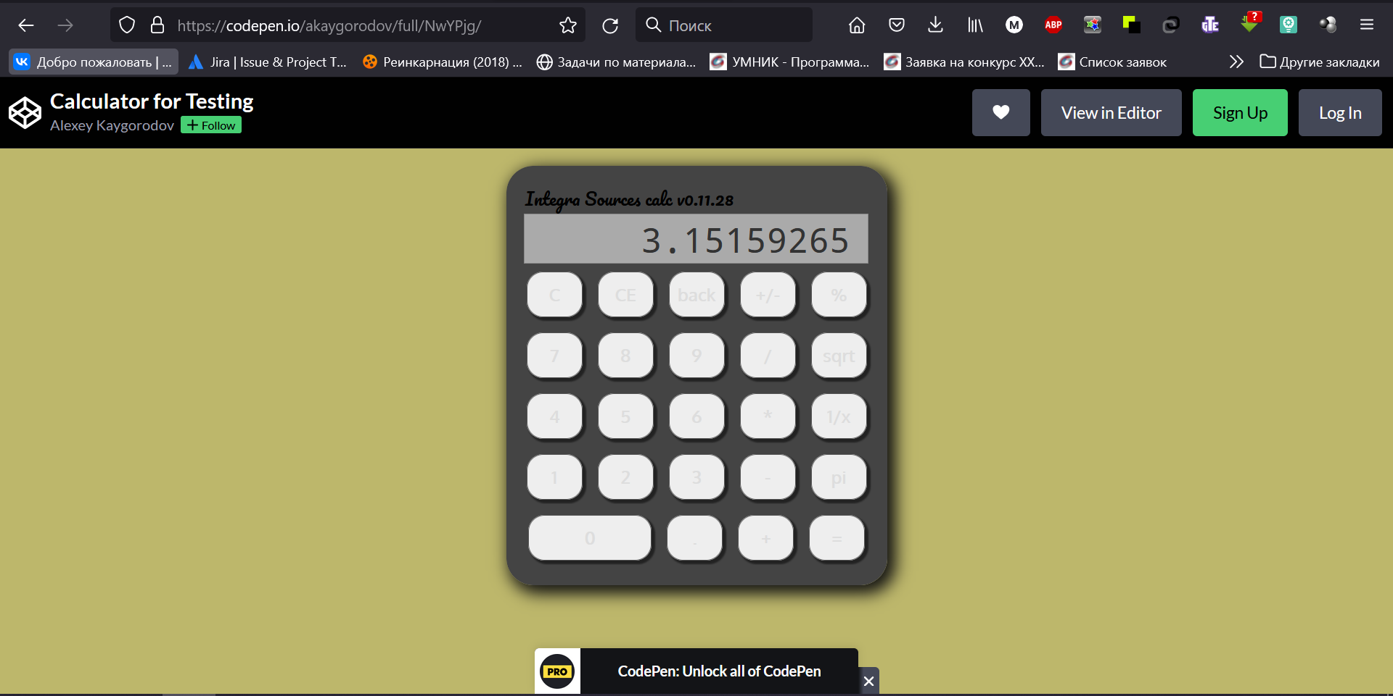

BR-2: Incorrect number is displayed in input field when pressing “8” button
Precondition: Site https://codepen.io/akaygorodov/full/NwYPjg/ is open
Steps | Press “8” button with mouse on calculator
Postcondition: Press “C” button
Actual result | Value “9” is displayed in input field
Expected result | Value “8” is displayed in input field
Environment | OS: Windows 10 x64 Pro, Version 2004  Browser: Mozilla Firefox  Version 96.0.x64
Video | https://drive.google.com/file/d/1NbjzVet_fv20DAM4P4NkefLAjoiEnSxk/view?usp=sharing

BR-3:Incorrect number is displayed in input field when pressing “9” button
Precondition: Site https://codepen.io/akaygorodov/full/NwYPjg/ is open
Steps | Press “9” button with mouse on calculator
Postcondition: Press “C” button
Actual result | Value “8” is displayed in input field
Expected result | Value “9” is displayed in input field
Environment | OS: Windows 10 x64 Pro, Version 2004  Browser: Mozilla Firefox  Version 96.0.x64
Video | https://drive.google.com/file/d/1G_axMFewUkwLd_rmpkfE1OWYlFxwG8ke/view?usp=sharing

BR-4: Zero is displayed in input field before value when pressing “+/-” button in empty input field
Precondition: Site https://codepen.io/akaygorodov/full/NwYPjg/ is open
Steps | 1. Press “+/-” button with mouse on calculator  2. Press “5” button with mouse on calculator
Postcondition: Press “C” button
Actual result | Value “05” is displayed in input field
Expected result | Value “5” is displayed in input field
Environment | OS: Windows 10 x64 Pro, Version 2004  Browser: Mozilla Firefox  Version 96.0.x64
Video | https://drive.google.com/file/d/1wgMG-2-E9PCz0IrD-0oCNNpolBjl3iP_/view?usp=sharing

BR-5: The input field deosn't clear when trying to re-enter after a successful calculation
Precondition: Site https://codepen.io/akaygorodov/full/NwYPjg/ is open
Steps | 1. Press “5” button with mouse  2. Press “*” button with mouse  3. Press “3” button with mouse  4. Press “=” button with mouse  5. Press “5” button with mouse
Postcondition: Press “C” button
Actual result | Value “155” is displayed in input field
Expected result | Value “5” is displayed in input field
Environment | OS: Windows 10 x64 Pro, Version 2004  Browser: Mozilla Firefox  Version 96.0.x64
Video

BR-6: Backspace button on physical keyboard doesn't delete last number in input field
Precondition: Site https://codepen.io/akaygorodov/full/NwYPjg/ is open
Steps | 1. Press “5” and “5” button one by one with mouse  2. Click on the input field after the value  3. Press Backspace button on physical keyboard
Postcondition: Press “C” button
Actual result | Value “5” is displayed in input field
Expected result | Value “55” is displayed in input field
Environment | OS: Windows 10 x64 Pro, Version 2004  Browser: Mozilla Firefox  Version 96.0.x64
Video

